

International Accelerator Program

Policy & Procedures Manual

Table of Contents

- IAP Programs & General Information……………………………………………………………..page 2-6

- ISSS Support of IAP, IAP Cycle…………………………………..…………………………………….page 7-9

- Admissions & Immigration Documents…………………………………………………………..page 10-21

- Program Tracks and Student Program Life Cycle…………………………………………….page 20-21

- Employment Authorization…………………………………………………………………………….page 21

- Immigration & Compliance Section…………………………………………………………………page 21-26

- Addendum……………………………………………………………………………………………………..page 27-29

IAP Programs & General Information

Common Terms:
‘IAP’– Umbrella name for all Accelerator Pathway Programs for UG and GR students and for the Nondegree Program American Collegiate.

*Students have NOT heard of Shorelight Education* - Do not use, it will confuse students. Use ‘Accelerator’ or ‘Collegiate or ‘IAP with students, campus, and IAP colleagues.

‘HQ’ or ‘Boston’: how IAP & ISSS distinguish between our IAP partners on AU’s campus and Shorelight Education employees working in the Headquarters in Boston.

‘The Field’: Means Shorelight Education (SE) offices abroad and their partner agents.

Communication Chain:
Student-Family-Agent-SE Agent-SE Regional Office-HQ Boston-IAP-AU Admitting Unit-ISSS

Program Tracks

Language Training Programs
Pre-Sessional GR Program (Entrance Level 5 or 6)
Pre-Sessional UG Program (Entrance Level 4 or 5)
Pre-Sessional Collegiate Program (Entrance Level 4 or 5)
From Summer 2021, each PSE program will be referred as:
- Level 4: PSE IAP/ACDC 2 term
- Level 5: PSE IAP/ACDC 1 term
- Level 6: PSE MAP 1 term

Pathway Programs
GR Level: Master’s Accelerator Program (MAP) 1-3 semester Pathway Program
MAP 1 (1 semester of pathway program)
MAP 2 (2 semesters of pathway program)
UG Level: International Accelerator Program (IAP) 2-4 semester Pathway Program
AAA – Adv Academic Accelerator Program (2 semesters of pathway program)
AAP – Academic Accelerator Program (2 semesters of pathway program)
EAP – Extended Accelerator Program (3 semesters of pathway program)

If students don’t meet progression requirements after completing the required number of terms AND they are academically eligible to extend program, students can extend their program by 1 term ONLY.

Accelerator students are considered non-degree at AU until they successfully complete the pathway portion of their program, and then will progress to the intended degree program. Students guaranteed admission to AU after meeting progression requirements.

Nondegree Program (2-3 Term Program)
American Collegiate Program – Nondegree UG program to earn credits and prep to transfer to degree program at other university.
UG Level Only:
ACCA – Adv American Collegiate 2 Term Program
ACC2 – American Collegiate 2-Term Program
ACC3 – American Collegiate 3-Term Program (summer required if not last term)

Like IAP/MAP students, American Collegiate students could also extend their program by 1 term should they not meet completion requirements.

Collegiate students do not have guaranteed admission to AU after completion of the program. Students are advised on transfer to other universities. If a student wants to attend AU, the student must apply as transfer student and are admitted/denied by the AU undergraduate admission office. Their applications are treated same as other international transfer students but the immigration process is considered as Change of Education Level (see the progression section).

ACDC students must enroll full-time continuously including summer.

Group | Summer Enrollment | Summer SEVIS Registration
Organic ELTA | optional | no
PSE (all) | required | yes
IAP | required | yes. Extenders are eligible for RCL
MAP | optional | no
ACDC | optional | no, unless student is an extender in which case summer becomes a required term

How to identify an Accelerator or Collegiate Student in SUNAPSIS:

Profile Status:
- Other Initial Student
- Other Active Student
  - Other: for IAP, MAP, and ACDC
- Language Training Initial Student
- Language Training Active Student

How to Find Program Name:
- Go to Records Management
- Click on Student Admission Information
  - Click on Admissions Information
- Or click on Student Academic Program Information
  - Click on Program Information
- Under ‘Academic Program’ you will see:
Master’s Accelerator Program 1 (GR) | MAP1 | Master’s Accelerator Program 2 (GR) | MAP2
Adv Academic Accelerator Program (UG) | AAA | Extended Accelerator Program (UG) | EAP
Academic Accelerator Program (UG) | AAP | Pre-Sessional English (UG or GR) | PSE
American Collegiate 2-Term Program (UG) | ACC2 | Adv American Collegiate 2-Term Program (UG) | ACCA
American Collegiate Pre-sessional (UG) | ACDCPSE | American Collegiate 3-Term Program (UG) | ACC3
*Make a habit of checking the Academic Program of each student you advise to be sure of which program.*

How Accelerator and Collegiate students may identify themselves:
**Students will NOT use Shorelight to identify themselves**
Words students may use: Accelerator program, MAP, AAA, AAP, EAP, pathway program, ELTA, Pre-sessional, Collegiate, Freshman, Master’s.

IAP Partnership Documents
These documents provide the requirements for admission and progression as agreed between IAP and AU. These documents are updated twice a year by the MESWG and Graduate Working Group.

4. G-2 Languages and Admissions Requirements Document
*Located -K:\ISSS\01-IAP\G-2 Documents
This document is specifically important to ISSS because it outlines the English Proficiency requirements for each program. We need this information in order to issue the I-20 immigration document. The English Language Assessment Equivalencies Table within the G-2 document is printed and hung at the desk of all admissions team members for use when issuing the I-20 documents. It is critical that only students with proper English proficiency are issued an I-20 document for an IAP program.

H-3 Progression Standards Document
*Located -K:\ISSS\01-IAP\H-3 Documents
This document is specifically important to ISSS because it outlines the academic requirements students must meet before being moved to the next level of study. Students who do not meet all these requirements cannot be issued the change of level I-20 immigration document. Juliana Fernandes, Advisor of Immigration & Compliance also reviews this information closely to ensure all students are meeting academic requirements of progression.

IAP Partnership Working Groups

MESWG – AAA, AAP, EAP, Pre-sessional
This is the Enrollment Services Working Group, which consists of representatives of IAP, ISSS, Office of Enrollment Services (Undergraduate Students only), Vice Provosts office. It meets quarterly to discuss issues of admission, immigration, recruitment etc. This group reviews the G-2 document on a yearly basis to ensure all policies and procedures are up to date.
IAP Director of Admissions (Pilar Menendez) heads the meetings, sends the invites and provides the agenda for all to add to for the quarterly meetings.

Graduate Committee – MAP, AMAP
Working group for IAP, ISSS and graduate admitting units. It meets quarterly to discuss issues of admission, immigration, recruitment etc. This group reviews the G-2 document on a yearly basis to ensure all policies and procedures are up to date.
IAP Director of Admissions (Pilar Menendez) heads the meetings, sends the invites and provides the agenda for all to add to for the quarterly meetings.

Admissions Working Group
This is a group that meets bi-weekly during certain parts of the year to discuss issues specific to the admissions and I-20 creation pipeline.
Members are
- Pilar Menendez (Director of Enrollment, Shorelight in Houston)
- Neon Yan (Shorelight in China)
- Page Sun (Admissions Advisor, Shorelight in China)
- Natalie Whiteside (Admissions Advisor, Shorelight in Boston)
- Joe Yuan (Senior Admissions Advisor, Shorelight in China)
- Anila Sula (Admissions Counselor, Office of Enrollment)
- Jordan Miles (Assistant Director, Office of Enrollment)

Collegiate Working Group
This group meets as needed to discuss issues specific to the change of level, completion of program or transfer-out for Access students. Because this is a Nondegree program that does not ‘progress’ there are slightly different processes that must be overseen.

Student Services Advisors Working Group
This group meets as needed to discuss issues specific to academic progress, maintaining F-1 status, change of level and progression, as well as workshops and events for IAP students.
Jawee Perla, Director of Student Services invites ISSS to meetings as necessary.

Contacts (Who/Where Located/What Program)

Name | Title | Office | Role | Work Phone | Personal Cell | Business Cell | Email
Sharmeen Ahsan-Bracciale | Managing Director | SVB-536 | Oversees Intl Acc. Programs, Enrollment | X8316 | 617-329-9504 | 202-465-6279 | Sharmeen.AhsanBracciale@AUACCELERATOR.COM
Jawee Perla | Director, Student Services | SVB-539 | All student services; advisors | X6980 | 202-746-1083 |  | jawee.perla@AUACCELERATOR.COM
Cecilia Guo | Student Services Advisor (PSE and IAP) |  | Advisor for PSE and IAP students |  |  |  | cecilia.gou@auaccelerator.com
Sara Tabarkakait | Student Services Advisor (MAP) |  | Advisor for MAP students
Pilar Menendez | Director, Admissions |  |  | X8310 |  |  | pilar.menendez@auaccelerator.com
Laura Parker | Assistant Academic Direcotr |  |  | X4724 |  |  | Laura.parker@auaccelerator.com

ISSS Support of IAP, IAP Cycle, & Front Desk IAP Data

SEVIS I-20 Immigration Document creation
☐ | PIIRF Submission  Review financial documents & English proficiency of all applicants and students up for progression.
☐ | Issue Initial, Transfer, Change of Level I-20’s for each Fall, Spring & Summer Term.
☐ | Work closely with DSO of previous institution to issue Transfer I-20 and maintain student status.
☐ | Provide workshops and advising on change of level immigration process, travel & re-entry during progression, collection of financial documents for all progressing students, close coordination with IAP staff, six admissions offices and OUR.
☐ | Ensure data integrity and consistency in Colleague, Sunapsis & SEVIS systems.

Orientation & Transition Support
☐ | International Student Orientation – Fall, Spring, Summer Terms
☐ | Global Café Events – Build Community, Highlight Student Support Offices at AU, 6 each semester
☐ | CARE Team – ISSS Advisor member of team, weekly meetings to support int’l students in crisis
☐ | Int’l Fall Gala & Spring Cultural Festival –Build Community, Share Culture with wider AU Community
☐ | AIC Support – ISSS Advisor actively involved in advocating and representing int’l students
☐ | Academic, Language & Cultural Transition Support – Connect with proper resources on campus
☐ | Walk-In Advising available Monday-Friday 9am-5pm throughout calendar year (pre-COVID time)

Required sevis registration & Check-in within 15 days each term
☐ | Ensure completion of required SEVIS registration each Fall, Spring, Summer Terms for ALL initial, Transfer-In, returning TLA & Change of Level IAP Students.
☐ | Ensure completion of required SEVIS check-in each Fall, Spring, Summer Terms for ALL continuing IAP students.
☐ | Constant email & phone call reminders to complete required SEIVS registration & check-in to ensure students remain in F-1 immigration status.
☐ | Ensure full-time enrollment of each IAP student at AU each Fall, Spring, Summer Term.
☐ | Process Reduced Course Load Authorizations in SEVIS for eligible students each Summer Term.
☐ | Finalize all other SEVIS records (Cancellation of no-shows & withdrawals, update deferred student records.

Student advising (walk-in’s, Typical issues, emails, calls, appointmetns)
☐ | Advise students daily on immigration, travel & re-entry, employment questions, academic issues, taxes, social security number, insurance requirements, transfer out, change of level, temporary leave of absence, adding/dropping courses, summer classes, reduced course load, program extension, personal crisis etc.
☐ | Walk-In Immigration Advising available throughout year - Monday-Friday 9am-5pm.

Policy, Procedures & Processes
☐ | Review initial & revised partnership program documents (Ex. G-2, H-3, web resources) to ensure compliance with immigration regulations.
☐ | Develop policies & protocols for academic and immigration compliance.
☐ | Create efficient procedures and processes that both support immigration policy and partnership requirements. Coordinate closely with IAP staff and AU campus partners (Admissions, OIT, OUR, Dean of Students, Associate Deans, Provost Office, General Counsel’s Office etc) to ensure all runs smoothly.

Crisis Management
☐ | Provide country/region specific outreach and support during natural disasters, outbreak of unrest etc.
☐ | Keep students informed in a timely and effective manner of all updates to immigration regulations and laws to ensure maintenance of immigration status. (Travel Ban, Employment updates etc).
☐ | CARE Team – ISSS represented in AU CARE team, weekly meetings to support students in crisis. Coordinate with IAP and AU Campus Partners to support students.
☐ | Respond quickly and effectively to students in immigration, academic, personal, financial crisis.

Resource for iap & American colligiate staff
☐ | Act as constant resource for IAP and AU Campus Partners regarding immigration aspects of program.
☐ | Coordinate daily by email, phone, in-person/virtual meetings with IAP and AU Campus Partners regarding IAP students, policies & processes.
☐ | Director and ISSS advisor on MESWG Teams for IAP, MAP Programs – quarterly meetings (8 total).
☐ | Member of Admissions sub-committee for IAP, MAP & Collegiate Programs – bi-weekly meetings.
☐ | Front Desk ISSS Immigration Advising available for staff throughout year - Monday-Friday 9am-5pm  *Available in K-Drive/ISSS/01-IAP/Manuals  Eye View of SEVIS Actions Each Term:
 | 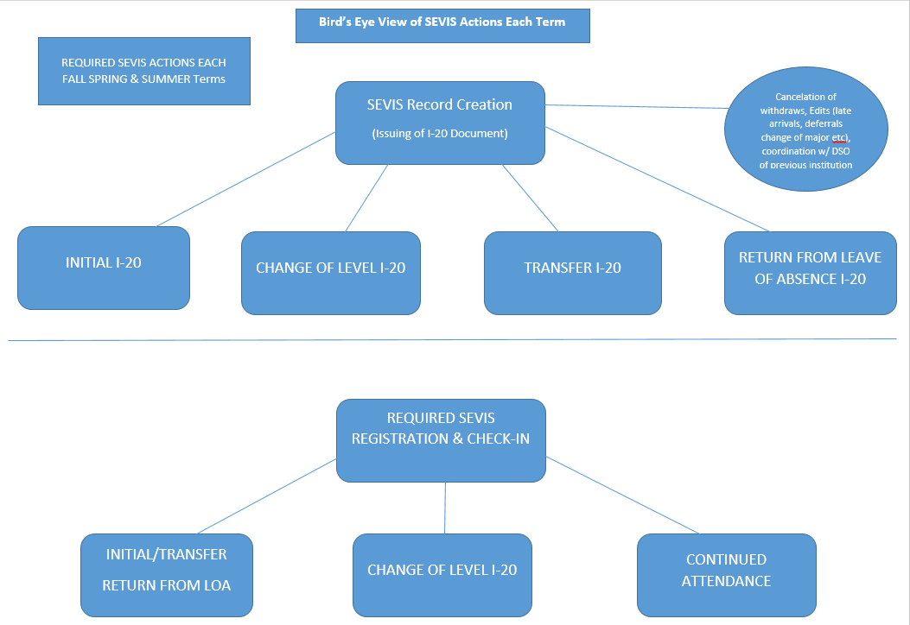

*Available in K-Drive/ISSS/01-IAP/Manuals

Admissions & Immigration Documents

An ‘Initial’ I-20 immigration document is issued for students currently outside the U.S. and wishing to request an F-1 student visa to enter the U.S. to study. Initial I-20 immigration documents for IAP are on a strict timeline, per agreement with the partnership. Within 10 days of a student’s application arriving at AU, an I-20 must be produced. Student’s whose applications or financial documentation are not in order will take longer.

We use a Smartsheet to keep track of where in process each student is between the three offices. (Smartsheets are discussed in more detail below).

Admissions & I-20 Issuance Timeline:

What is needed to issue an Initial I-20 Document
- Admission record: Student must be admitted to an IAP Program by an AU admissions office.
  - The Office of Enrollment: Responsible for all UG PSE, IAP, ACDC students
  - Graduate admission offices: Responsible for GR PSE, MAP students in their respective school.
- English Proficiency scores must meet program requirements.
  - Pre-Sessional: English proficiency is not required for I-20 creation purposes, and it will be marked as “Not required” on their I-20, however, Pre-Sessional students should still show sufficient English testing score to meet program admission requirements outlined in the G-2 documents.
  - Pathway Program: Must meet program requirements, as outlined in the G-2 documents and may NOT meet direct entry requirement.
  - Collegiate Program: Must meet program requirement, as outlined in G-2 document. May meet direct entry requirement because it’s a Nondegree program and admission to AU is not guaranteed.
- Bank Documents: Students must prove amount needed for the first year of the program they are admitted to. To selected students, Shorelight provides tuition waiver in a form of scholarship, which will be included in the I-20 financial information.
- Certification of Finance form: All financial sponsors must sign the Certification of Finance form. This form is different from AU’s CFIS form and specific to IAP/MAP/PSE/ACDC.
- I-20 Request form: In addition to the Certification of Finance form, students submit this I-20 request form where students’ personal information (e.g. foreign address, birth city, birth country) can be found. US address must be included for transfer-in students.
- If students have dependents, must provide funds to cover the number of dependents and provide the biographical page from passport for each dependent.

Sunapsis ‘Templates’ will auto-populate most information based on the program code, however, IAP & MAP I-20’s require the DSO to hand enter students’ intended major into the I-20 program information and the remarks under I-20 Financial Information.

Education Level is “Other: Pathway Program” for MAP & IAP or ‘Nondegree Undergraduate’ for Collegiate. Pre-sessional education level is Language Training.

Major 1 (CIP Code 32.0109 for IAP & MAP and CIP 30.9999 for Access)
- Major 2 (CIP Code of intended major – for IAP & MAP ONLY)
- I-20 Remarks: the XXXX must be replaced with name of intended major (for IAP & MAP ONLY)

*See K:\ISSS\Sunapsis\After Site Visit\User Guide\0 SUNAPSIS FINAL GUIDE in K-Drive for screen shots on how to issue an initial I-20 document using RTI Embedded Browser in Sunapsis.
**OUR’s CIP Code list can be found in K:\ISSS\ADMISSIONS\CIP Codes&EV Position Codes in K-Drive

I-20 Document Creation Cheatsheet:

* This table available in K-Drive/ISSS/01-IAP/Manuals

Transfer I-20 Documents
If a new IAP student currently in the U.S. on an F-1 visa wishes to transfer their SEVIS record to American University, ISSS can create a “Transfer I-20” immigration document. In addition to what is required for initial I-20s, the student must submit the AU Transfer-In form, signed by the student and current DSO at the other school. IAP Admissions will forward this form to ISSS as soon as it is received, or ISSS may receive it directly from student or DSO.

*The electronic Transfer-in form is NOT used by IAP applicants as students typically don’t have access to AU account until after they are fully admitted.

ISSS keeps track of transfer release dates in SEVIS Transfer-In List. Per agreement with partnership, ISSS creates the Transfer I-20 document within 2 business days of the SEVIS release date. If a record is not released by the date listed on the AU Transfer-In form, ISSS will contact DSO at current school to remind to transfer the record.

The Transfer I-20 documents can be issued ONLY after the student’s SEVIS record is transferred to AU.

What is needed to issue a Transfer I-20 Document
- Student must be admitted to an IAP Program by an AU admissions office.
- English Proficiency scores
  - Pre-Sessional: Student must meet G-2 requirements for Pre-sessional program. However, English proficiency requirement on I-20 is indicated as “Not required” because pre-sessional is considered as an intensive English program,
  - Pathway Program (IAP & MAP): Must meet program requirement, as outlined in the G-2 document and may NOT meet direct entry requirement.
  - Access Program: Must meet program requirement, as outlined in G-2 document. May meet direct entry requirement because in a Nondegree program.
- Financial Documents must prove amount needed for IAP program admitted to and all financial sponsors must sign the Certification of Finance form.
- I-20 Request form: This form is specific to IAP students.
- AU Transfer-In form signed by student and DSO of current institution
- A non-U.S. address and a U.S. address
- If have dependents, must provide funds to cover the number of dependents and provide the biographical page from passport for each dependent.
- SEVIS record is transferred to AU

Sunapsis Admissions ‘Templates’ will auto-populate most information based on program code, however, IAP I-20’s require the DSO to hand enter into RTI Embedded Browser:
- The ‘Other’ type (‘Pathway Program’ for MAP & IAP or ‘Nondegree Undergraduate’ for Access
- Major 1 (CIP Code 32.0109 for IAP & MAP and CIP 30.9999 for Access)
- Major 2 (CIP Code of intended major – for IAP & MAP ONLY)
- I-20 Remarks the XXXX must be replaced with name of intended major (for IAP & MAP ONLY)
*See K:\ISSS\Sunapsis\After Site Visit\User Guide\0 SUNAPSIS FINAL GUIDE in K-Drive for screen shots on how to issue an initial I-20 document using RTI Embedded Browser in Sunapsis.
**OUR’s CIP Code list can be found in K:\ISSS\ADMISSIONS\CIP Codes&EV Position Codes in K-Drive

Step by Step Process to Create I-20
- Admitting unit submits “PIIRF” e-form through Sunapsis
- The e-form will appear on the New Student IAP & MAP on the “PIIRF submitted stage” checklist once it’s submitted
- Open the student record and check the e-form.
  - Check the key pieces of information.
    - Admit term program, visa type, scholarship, English test…etc
- If the student is undergraduate level, download documents from Perceptive Content and upload them to the e-form on the “Document Management” tab.
- Check the following items:
  - Student’s record
    - Address (Record Management > Biographical Information > Addresses)
      - All initial students must have a foreign address
      - Transfer students must have a US address
        - *If the US address is populated for non-transfer students, delete records and keep the foreign address only.
    - Academic Information
      - Admission Information (Record Management > Student Admission information)
        - Admit term
        - Application status must be “Admitted”
        - Check the program track information (AAP, AAA, EAP, PS….etc.)
          - Make sure that the program track on the admission information matches what is listed on the PIIRF
      - English proficiency (Student Admission Information > English Proficiency Scores)
        - Must meet requirements for the program track according to G-2 documents
        - G-2 documents can be updated. Request for an updated version before issuing I-20s for the upcoming Fall semester.
        - If EP scores not found in Sunapsis record, check the Smartsheet to see if a Duolingo test score sheet has been shared.
  - Passport to confirm the following items in Sunapsis match
    - Name order matches with Machine Readable Zone
    - Gender
    - Date of Birth
    - If the passport is expiring within 6 months of the student’s arrival, let IAP admissions team know. (via Smartsheet)
  - I-20 Request Form
    - Properly filled out
    - Check if the city of birth matches what’s listed on PIIRF
    - Check if the non-AU email address is correctly entered in the PIIRF
    - Check the US address provided (for transfer-in students only)
    - Signed by the student on the second page
    - Check the intended major (for IAP and MAP students) and also cross-check on Smartsheet
  - CFIS
    - Check the student’s name
    - Check the sponsor’s name
    - Check the second page is filled out & signed by the sponsor
  - Financial documents
    - Check the document is issued within the 3 months of the Shorelight “Approved” stamp
    - Check the document has…
      - Account holder’s name
        - The name on the financial document must match with CFIS
      - Official logo/letterhead
      - Account type (checking, saving, credit…etc)
      - Currency type
      - Bank address & contact information
      - Signed by bank official
      - Official seal/stamp
- Check off tasks on the checklist
- Apply a template:
  - Select a correct template under the American University > IAP > Respective template (IAP, ACDC, PS, or MAP)
    - Copy other email addresses and paste them into the university email field
- On the I-20 Program Info and I-20 Financial Info tabs after applying a template…
  - I-20 Program Information
    - Enter Second Major CIP code (for IAP & MAP students)
      - Look up CIP code on this list: ..\ADMISSIONS\CIP Codes & EV Position Codes\2020 Updated List of Active Academic Programs 02072020 from OUR.xlsx
  - I-20 Financial Information
    - Enter funding information
    - Enter remarks with intended major (for IAP/MAP only)
- Launch the RTI SEVIS browser & create new I-20

Memo:
Funds are typically listed as Family Funds, Personal, or foreign government names (UAE Government, Saudi Arabia Government, Government of Indonesia…etc.)

IAP Scholarship is listed as “Intl Accelerator Scholarship” and must be issued under the “Other Funds” section.

If students are funded by both family and IAP scholarships, type “Intl Accelerator Scholarship & Family” so the text doesn’t get cut off.

Students on visas other than F-1 Student

J-1 Exchange Visitor – Nondegree Student, Undergraduate Student, or Graduate Student Categories:
A student whose government sponsorship requires the student to be on a J-1 EV visa may participate in the IAP program. However, these students must be pre-approved by ISSS before moving forward with student application. These students must be closely advised on the requirements of the visa. Each change of category (pre-sessional to EAP, EAP to Bachelor’s) will require the student to return home and request a new J-1 visa for the next phase of the program. This is because the purpose of the EV activity changes with each change of category. The student must be closely monitored and advised to ensure a new J-1 visa is received with each new DS-2019 issued. IAP has never yet sent us a J-1 student yet.

PR, PPR & U.S. Citizens
Permanent Residents, Pending Permanent Residents and U.S. citizens are not eligible to be a part of the IAP program – per Shorelight Education Policy

Students on other non-immigrant visas (A, G, etc) are able to participate in the IAP programs – as long as their visa status permits full-time study. These students do not require I-20 or DS-2019 immigration documents to be issued by our office. These students must continue to receive immigration advice from their visa sponsors. ISSS will assist with academic and cultural adjustment support only. These students do not need to submit the Certification of Finances, I-20 Request form or financial documents to ISSS because they are not requesting an immigration document from our office.

B-1/B-2 Tourist Visas
Students on B visas CANNOT engage in full-time or part-time study in the IAP program. Changing status from B to F within the U.S. is not recommended.

Change of Status

From Another status to F-1
Student must set up an appointment with ISSS to discuss immigration options. Typically, ISSS encourages all students to change visa status by departing the U.S., obtaining the new visa and re-entering on their new visa status. This is the quickest and easiest way for a student to ‘re-set’ a visa status in the United States. ISSS will issue an I-20 Document upon the request of the student after the student has been admitted to the IAP program and provided the financial documents and copy of passport biographical page.

F-1 to another Status:
Not permitted by Shorelight Education Policy. Must be referred to IAP with questions about this.

Pro gression & Change of Level Immigration Documents:

Progression & Change of Level Definition
‘Progression’ is the academic completion of one part of program (Pre-sessional/Pathway/Nondegree) and movement on to the next level of the program (Pathway/Nondegree/Bachelor’s/Master’s).

Progression Types:
- Pre-sessional (PSE) to IAP (EAP)
- Pre-sessional (PSE) to MAP (MAP 2)
- Pre-sessional to American Collegiate(ACDC)
*Pre-sessional to IAP/MAP/ACDC is internally called “Advancement” by the Shorelight team. They don’t consider these students as moving out of their programs, however, PSE students must also be included in the progression-related communications/processes. Make sure that a progression students list provided by the Shorelight team also includes PSE students as they are often left off.
- IAP to Bachelor’s
- MAP to Master’s
- American Collegiate (ACDC) to Bachelor’s
  - NOTE: ACDC students who successfully completed their program and are accepted by AU are treated as Change of Level students from the immigration perspective. However, they are academically “transfer” students since their admission to AU is not guaranteed upon acceptance to the ACDC program. ACDC students apply to AU just like other academic transfer students and they must be accepted by OE. Their acceptance is contingent upon their English Proficiency or successful completion of ACDC. Not all ACDC students will attend AU and every year many ACDC students request transfer-out.

‘Change of Level’ is the change in an Education Level during the course a student’s studies which will require a new I-20 immigration document to be issued.

As students move from one education level to another, they must obtain a ‘Change of Level’ I-20 document. Shorelight refers this process as “progression”. ISSS provides Progression Workshops each term for students who are scheduled to progress to the next education level. This is a sensitive time for the student’s immigration record and students must be advised and must follow directions accordingly or risk putting their immigration status in jeopardy.

Change of Level Immigration Document Process:
IAP program has three progression times throughout year: May, August & December.
*A fourth progression in June (end of 1st summer term) may exist for Pre-sessional students moving to IAP/MAP/ Collegiate or if there are any IAP students in a probationary term and all progression requirements are met after end of 1st summer term.

Progression Process for IAP/MAP/PSE students:

This process should begin about 2.5 months prior to the end of the semester. Start communication with IAP early to ensure a smooth progression process.
- IAP provides ISSS with a list of all students ‘scheduled for progression’ at the end of the current term. This means, if this student meets all progression requirements at end of the term, then they will move on to the next stage of the program.
  - Make sure to reach out to the Collegiate team to collect a list of students who are completing either ACDC PSE or ACDC and intending to transfer to AU for undergraduate.
  - Pre-sessional students tend to be left off of this list because they are still IAP students after changing education level. Make sure to receive their information from the IAP team.
- IAP creates a Progression List in Smartsheet (using previous progression terms as a template)
- ISSS team notes I-20 expiration, visa expiration, passport expiration in Smartsheet to determine ‘priority students’ during progression process
- IAP/ISSS identify dates around 5-6 weeks into term for the ISSS led ‘Progression Workshop’ explaining the change of level process and what is needed to issue the new I-20 to progressing students.
- There are 3 workshops for PSE students (PSE to IAP, PSE to MAP, PSE to ACDC), 1 workshop for IAP to Bachelor’s, 1 workshop for MAP to Master’s, 1 workshop for ACDC to Bachelor’s.
*More information can be found in the K drive under ISSS – IAP - ‘Progression Workshop (COL)’.
- An IAP Student Services Advisor will book rooms, invite students by email and in class announcements, and manage catering for Progression Workshops for PSE to IAP/MAP, IAP to Bachelor’s, and MAP to Master’s.
*Since the pandemic, these progression workshops have taken place virtually. Different time options (AM, PM, in the evening, early morning) were offered to accommodate student’s schedule/time difference.
- A Collegiate Advisor will book rooms, invited students by email, and manage catering if necessary for Progression Workshops for PSE to ACDC and ACDC to Bachelor’s.
*ACDC to Bachelor’s workshop typically coincides with their ACDC completion workshop.
- ISSS advisor will take attendance, give workshops and provide a Q&A session at end.
- ISSS to send follow-up email after workshop with reminders and instructions (maintain F-1 status, provide financial documents, meet all progression requirements). *Email templates in K-drive under ISSS – IAP – Progression Workshop (COL)
- IAP team to follow up with all students with expiring I-20s or visas to gather information on travel plans and foreign mailing address to receive new I-20 if necessary.
- ISSS to email all non-attendees and set up a make-up session or meet individually with each student that did not attend the workshop.
- Students begin to collect required financial documents for a deadline of one month after the Progression Workshops.
- ISSS to send out reminder emails about financial document submission intermittently to progressing students.
- ISSS to review and confirm financial documents as they are submitted and get back to students for clarification or new documents, as needed.
- 72 hours after last day of term Faculty to submit final grades for all courses.
- IAP to review students for progression and send final report to ISSS within 5 days of grades due.
- Undergraduate & Graduate admissions units to close previous program, admit students to new program and submit PIIRF within 5 days of final report from IAP.
- ISSS to create new COL I-20’s within 2 days of receiving the PIIRF with deadline to create the COL I-20 the Friday before first day of classes.
- For students with expiring I-20s or visas, ISSS will prioritize I-20 creation and request that admission units expedite mailing process. Admissions units will utilize travel plans and foreign mailing address already gathered earlier in the process (See step 10).
*Students already notified during Progression Workshop that they will need new I-20 to either re-enter the United States if current I-20 is expiring or need new I-20 if renewing visa.
- August/December progression: Students to pick-up new I-20 by first day of classes. If expiring I-20 or visa, new I-20 to be mailed to them if travelling.
- May progression: Students to pick-up new I-20 as soon as possible and by first day of class. If expiring I-20 or visa, new I-20 to be mailed to them if travelling.
- Mailing: IAP to mail COL I-20’s for students moving on to IAP/Access/Bachelor’s; Graduate Admissions units to mail COL I-20’s for students moving to MAP/Master’s.
- Students to come to ISSS individually to discuss any plans for travel. An ISSS Advisor will review the specific immigration, academic and personal situation of each student and determine if travel is advisable during COL.
*See K:\ISSS\Sunapsis\After Site Visit\User Guide\0 SUNAPSIS FINAL GUIDE in K-Drive for screen shots on how to issue a Change of Level I-20 document using RTI Embedded Browser in Sunapsis. RTI Embedded Browser is always recommended.

Progression Process for ACDC students:
This process should begin about 2.5 months prior to the end of semester. Start communication with Collegiate team early to ensure a smooth progression process.
- Collegiate, OE, and ISSS reviews completion timeline and schedule a date for a completion workshop.
- Collegiate provides ISSS with a list of all students who will be completing ACDC at the end of the current term. Meaning, if this student meets all requirements and is accepted into AU at end of the term, then they will move on to next stage of program..
- Collegiate creates a Transfer Report in Smartsheet
- ISSS team notes I-20 expiration, visa expiration, passport expiration in Smartsheet to determine ‘priority students’ during progression process
- About a month to 1.5 month before the end of each semester, Collegiate, OE, ISSS will collaboratively offer “Completion Workshop” to completing ACDC students.
  - From ISSS, we cover immigration options students can pursue after the completion of ACDC:
    - Attend AU
    - Transfer to another school
    - Leave the U.S.
    - Change status to another visa
- A Collegiate Student Services Advisor will book rooms, invite students by email and in class announcements, and manage catering for Completion Workshops
- ISSS advisor will give workshops and provide a Q&A session at end.
- ISSS to send follow-up email after workshop with reminders and instructions (maintain F-1 status, provide financial documents, meet all progression requirements).
- IAP team to follow up with all students with expiring I-20s or visas to gather information on travel plans and foreign mailing address to receive new I-20 if necessary.
- ISSS to email all non-attendees and set up a make-up session or meet individually with each student that did not attend the workshop.
- 72 hours after last day of term Faculty to submit final grades for all courses.
- Collegiate to review students for progression and send final report to ISSS within 5 days of grades due.
- Office of Enrollment to close previous program, admit students to new program and submit PIIRF within 5 days of final report from Collegiate.
- ISSS to create new COL I-20’s within 2 days of receiving the PIIRF with deadline to create the COL I-20 the Friday before first day of classes.
- For students with expiring I-20s or visas, ISSS will prioritize I-20 creation and request that admission units expedite mailing process. Admissions units will utilize travel plans and foreign mailing address already gathered earlier in the process (See step 10).
*Students already notified during Progression Workshop that they will need new I-20 to either re-enter the United States if current I-20 is expiring or need new I-20 if renewing visa.
- August/December progression: Students to pick-up new I-20 by first day of classes. If expiring I-20 or visa, new I-20 to be mailed to them if travelling.
- May progression: Students to pick-up new I-20 as soon as possible and by first day of class. If expiring I-20 or visa, new I-20 to be mailed to them if travelling.
- Mailing: IAP to mail COL I-20’s for students moving on to IAP/Access/Bachelor’s; Graduate Admissions units to mail COL I-20’s for students moving to MAP/Master’s.
- Students to come to ISSS individually to discuss any plans for travel. An ISSS Advisor will review the specific immigration, academic and personal situation of each student and determine if travel is advisable during COL.
NOTE: Unlike IAP/MAP progressing students, ACDC students submit financial documents (bank document & CFIS) at the time of application to AU. The only document students need to submit after their acceptance into AU is the enrollment agreement.

How to Create COL I-20
- Admission office submit COL PIIRF
  - Pre-sessional > IAP/MAP/ACDC progressing students’ PIIRF will be on the “COL IAP & MAP PIIRF” checklist (*No PSE to MAP COL students in the Spring/Summer 2020 to Fall 2021 cycle.)
  - IAP/MAP/ACDC > Degree students’ PIIRF will be on the “COL Degree” checklist
- Check if student’s passport on file has expired or not
- Open the e-form and check the following:
  - Admitted term, program, English proficiency (must say “Met progression requirements”)
  - For students progressing from PSE to IAP/MAP, check their intended major.
- Check “Admission Information” under record management > Student Academic Record
  - Make sure the program the student admitted to for the upcoming term is entered and matching with what is listed on the COL PIIRF.
- Under the e-form management check “Financial Documents Submission”
  - By the time COL PIIRF is submitted, financial documents should have been approved as the deadline for students to submit documents is before their progression is confirmed.
  - In some cases, students submit documents through email or through another e-form. Check notes to see where documents are located if you can’t find the financial documents e-form.
  - Double check the financial document & source of funds
- Apply a template
  - Run a template for the program the student is progressing to
    - Undergraduate program: Regular > Undergraduate
    - Graduate program: Regular > Respective program under “Regular”
    - IAP/MAP/ACDC: IAP > Respective program under “IAP”
- Edit I-20 Financial Information
  - Copy the previous I-20 SEVIS ID number and paste into the new financial record.
  - Enter the amount and source of funds.
  - For most progressing students, their financial sponsor is either family or themselves (personal). There are a few students sponsored by their home country government.
  - Update Remarks:
    - Remove the existing remarks and replace with the respective remark appropriate for the type of progression from the template: K:\ocl\ISSS\ADMISSIONS\COL\Fall 2021 COL
- Edit I-20 Program Information
  - Copy the previous I-20 SEVIS ID number and paste into the new financial record.
  - Enter the CIP code:
    - For students progressed to degree: Copy & paste the CIP code from the newest admission record. Save.
    - For students progressed to IAP/MAP: Look up a CIP code for their intended major and enter the code as second major. Save
- Open RTI Browser
  - Select “Active” record and do the following steps through the Actions:
    - Shorten Program: Shorten the student’s previous program to the last day of enrollment. (Typically the graduation day. Last day of classes for summer.)
    - Change Education Level: This will create a new COL I-20. Click “Populate Fields” and populate information from the “Initial” I-20 Program information. For the financial information, you must bring the most updated record or judge based on the amount of tuition.
- Print I-20
  - Sign electronically and print as PDF, save on your computer.
  - Upload the I-20 through the Direct Document Download by looking up the student’s AUID.
- Approve COL PIIRF
  - Approve the COL PIIRF and send the auto-generated email to the student.
- Update Smartsheet
  - After COL I-20 is issued, update the progression smartsheet “Status” column and the I-20 issued date.
- Update Core Biographical info
  - Change to “Active COL student”

Resources for COL:
- Progressors lists shared by Amy are located in: K:\ocl\ISSS\IAP\Progression Workshop (COL)\Progression to Summer & Fall 2021\Progression List

Collaborative Management Tools

- Smartsheets: Student Tracking System www.smartsheet.com
Managing the issuance of immigration documents for IAP students is a collaborative effort across three main partners: ISSS, IAP & the Admissions Units (UG Office of Enrollment, & Graduate Levels for CAS, SPA, KSB, SOC, SIS, and SOE). Each office has a role to play in insuring I-20 documents are issued in a timely manner. We use Smartsheets to keep track of where in the pipeline a student is and what task each office has completed.
To create an account, have someone share a sheet with you by email, then follow prompts to create your own Smartsheet account, using your AU email.

- Summer-Fall 2022 IAP/ACDC Applications
- Summer-Fall 2022 MAP Applications
- Spring 2023 IAP/ACDC Applications
- Spring 2023 MAP Applications
- Spring 2022/Summer 2022 Progression
- Progression Summer to Fall for Access
- Progression Spring to Fall for MAP

Yui Itokawa and Anna Tigan in ISSS have access to these sheets. Admitting units and IAP staff also have access. Anyone with access can share the link with you.
*Progression Email Templates & Timelines in K-Drive-ISSS-IAP-Progression folder

- Email Templates K:\ISSS\00-Email Templates\Admissions

Program Tracks and Student Program Life Cycle
The table below shows students’ life cycle in each program track. The number after the program acronym indicates the term in which students are in. (e.g. PSE 1 = Pre-sessional in 1st term, EAP-EXT = EAP extension term). Pre-sessional students can only advance to the lowest track of the next level (EAP/ACC3/MAP2).
Program Track | Term 1 | Term 2 | Term 3 | Term 4 | Term 5
IAP/ACDC PSE  2 terms | PSE 1 | PSE 2 | EAP1/ACC3-1 | EAP2/ACC3-2
 |  |  | PSE-EXT | EAP1/ACC3-1
IAP/ACDC PSE  1 term | PSE1 | EAP1/ACC3-1 | EAP2/ACC3-2 | EAP3/ACC3-3 | UG/Transfer
 |  | PSE-EXT | EAP1/ACC3-1 | EAP2/ACC3-2 | EAP3/ACC3-3
EAP | EAP 1 | EAP 2 | EAP3 | UNG
 |  |  |  | EAP-EXT | UNG
AAP | AAP1 | AAP2 | UG
 |  |  | AAP-EXT | UG
AAA | AAA1 | AAA2 | UG
 |  |  | AAP-EXT | UG
MAP PSE  1 term | PSE 1 | MAP2-1 | MAP2-2
 |  | PSE-EXT | MAP2-1
MAP PSE  2 terms | PSE1 | PSE2 | MAP2-1
 |  |  | PSE-EXT | MAP2-1
MAP 2 | MAP2-1 | MAP2-2 | GR | GR
 |  |  | MAP2-EXT | GR
MAP1 | MAP1-1 | GR | GR
 |  | MAP1-EXT | GR
ACC3 | ACC3-1 | ACC3-2 | ACC3-3 | UG or Transfer
 |  |  |  | ACC3-EXT | UG or Transfer
ACC2 | ACC2-1 | ACC2-2 | UG or Transfer
 |  |  | ACC2-3 | UG or Transfer
ACCA | ACCA-1 | ACCA-2 | UG or Transfer
 |  |  | ACCA-EXT | UG or Transfer
*MAP students are NOT enrolled in summer. ACDC students are NOT supposed to complete their program in the summer term unless unexpectedly extend their program. These students skip summer sessions.

Employment Authorization

Education Level:
Other – Pathway Program (AAA, AAP, EAP, MAP, AMAP): On-campus employment only w/ proper authorization from ISSS Office. No authorization for off-campus work available. Time in Pathway Program WILL NOT count towards the 2 semester full-time requirement for CPT/OPT when progressed to degree seeking program.

Other – Nondegree Undergraduate (Access): On-campus employment only w/ proper authorization from ISSS Office. No authorization for off-campus work available.

Language Training Program (Pre-Sessional): On-campus employment only w/ proper authorization from ISSS Office. However, working is discouraged by academic advisors and ISSS in order to focus on language acquisition. Time in Language Training WILL NOT count towards the 2 semester full-time requirement for CPT/OPT when progressed to degree seeking program.

Immigration & Compliance Section
*Full policy summary chart K:\ISSS\01-IAP\Manual\ELTA IAP ACCESS Immigration Policy Summary Chart

Required Class Attendance:
Pathway and Language Training education level programs have a required attendance, per F-1 immigration regulations.

Continuous Attendance:
Students in Pathway and Pre-Sessional Program must attend their program in consecutive terms, which includes summer, with the exception of the AMAP, MAP and Access programs. When ready to return, the student must provide new proof of financial documentation in order to receive an initial I-20.

Online Courses:
Students in Pathway and Language Training education levels are not permitted to take online courses. All classes must occur in-person, following the prescribed curriculum as a part of the required class attendance policy.

Reduced Course Loads:
Not an option for students in a Pathway or Language Training program levels—all Pathway or Language Training students who complete their program in the summer must enroll full-time. The only exception to this rule is if the students extend their program into summer and only need to take fewer than full-time credits to complete the program. Their advisors submit RCL directly ISSS (Julie).

Leave of Absence:
Medical Leave of Absence only. Pathway & Language Training education levels are eligible for medical leave of absence only. This means medical issue of student, not family members. Any other leave taken would be considered a voluntary withdraw. Refer students interested in LOA to Julie Fernandes in ISSS.

If a progressing student within IAP (e.g. PSE to EAP) takes a medical leave, it’s processed as 1) Medical TLA for the Dean of Students, 2) Completion of PSE I-20 and Cancellation of COL I-20 for ISSS (if issued), and 3) withdrawal for EAP and the student needs to reapply for EAP.

If a progressing to degree student wishes to take a TLA in the first semester, that should be handled by academic units as decisions are different depending on the school For ISSS, student’s previous record will be completed and COL I-20 will be cancelled if already issued. The student will return on an Initial I-20.

Administrative Separation
A student who does not progress to next education level during program will receive an administrative separation. IAP to send final list of students to ISSS at end of each term. Student must be advised by ISSS on immigration implications of dismissal IN PERSON. Usually students will meet with Julie to discuss timing of departure, flight details etc. ISSS will email final SEVIS termination warning to student.

Voluntary Separation:
Students may voluntarily leave the program and AU at any time. Student must come to ISSS IN PERSON to receive immigration advising and ISSS must sign the ‘Withdraw from All Classes or ‘Registration Action’ form. ISSS will advise on immigration consequences of withdraw. Once OUR updates student’s record, ISSS will send official termination warning to student.

Transfer-Outs:
- We transfer students only at end of term.
- Student in good standing: May transfer SEVIS record at end of term, otherwise the SEVIS record will be terminated due to ‘Authorized Early Withdraw’
- Terminated student: AU will transfer SEVIS record to another school in terminated status. Refer student to DSO in new school for next steps about re-instatement.
Travel & Re-entry:
Students must have:
- Most recent I-20 document
- A valid travel signature on the back of their I-20 to re-enter the U.S. (good for 12 months)
- A valid, unexpired F-1 visa
- A valid passport with an expiration date at least 6 months in the future
- Copy of next term course schedule*
- Copy of AU Transcript*
- Financial Documents proving can pay for at least one year of cost of attendance for program*
- ISSS contact information*
*Good to have on hand in case of extra questions from Port of Entry Officer

Change of Programs for MAP students
- In principle, MAP students cannot change their intended program while they are in MAP.
- If a student wishes to change programs upon successful completion of MAP, the student must seek and secure direct admission to a new program while in MAP.
- Once they progress, they will move to the intended program first then withdraw from that in order to switch to a new program.
- ISSS will then create a new I-20 with the new program information before the add/drop deadline of the semester.

Change of Level Students Scenarios
- Temporary Leave/deferral
  - IAP/MAP students who successfully progressed to degree programs may be eligible for a temporary leave but it must be approved by their new academic unit. Students must work with the IAP student service team to communicate with the new academic unit upon successful completion of their program.
  - Pre-sessional students who progressed to IAP/MAP are not eligible for a regular temporary leave. If a student wishes to take a semester off, then they must voluntarily withdraw from AU then “reapply” for a respective IAP/MAP program before returning.
  - ACDC students who successfully completed and matriculated to AU can either defer their admission or take a leave of absence in their first degree semester but it must be approved by academic units.
- Summer enrollment:
  - If any IAP/MAP/Collegiate students who complete their program in the spring semester wish to stay in the U.S. and take summer classes, they are able to take classes through close communication with their new academic advisors.
  - New AA will create a non-degree program code for students so they can enroll between programs. The non-degree program code must be closed when the fall semester starts.
  - A new admission record for a degree program must be created for the I-20 issuance purposes.

Withdrawal
- Withdrawal before the program start date/initial students’ withdrawal
  - Students can withdraw their application or decline acceptance into IAP programs at any point before the program starts. The IAP team will send withdrawal notices to involved parties including ISSS. When a withdrawal notice was shared, check students’ SEVIS status.
    - If I-20 not created: forward the notice email to ieagle@american.edu for record.
    - If I-20 created: forward the notice email to ieagle@american.edu and remove the student from the New Student checklist. Create a separate Excel list for “I-20 to be canceled” so their I-20 will be canceled AFTER the semester starts.

Communication:
Any questions regarding the student’s immigration record, immigration status or F-1 visa should be directed to ISSS. When in doubt, please call, email or send student to ISSS!

Name | Title | Email | Phone | When To Contact
Front Desk |  | isss@american.edu | X3350 | Quick Questions
Senem Bakar | Director | sbakar@american.edu | X3352 | Policy issues, I-17, program changes
Yui Itokawa | Advisor, Immigration & Programming | yitokawa@american.edu | X3356 | Admissions req, fin docs, I-20’s, transfer-out, G-2, travel,
Alyssa Sistare | Senior Advisor, Immigration & Compliance | asistare@american.edu | X3351
Nicole Powers | Advisor, & Retantion | bbaxter@american.edu | X3358 | AIC violations, attendance issues, H-3
Juliana Fernandes | Advisor, Immigration & Compliance | jfernand@american.edu | X3355 | Immigration & Compliance Issues
Mira Hoxha | Assistant Director | fhoxha@american.edu | X3353 | Back-up for Admissions req, fin docs, I-20’s, transfer-out, G-2, travel,
Anna Tigan | Associate Director | atigan@american.edu |  | F-1 transfer out, orientation

Immigration Document Issuance & Advising Cycle: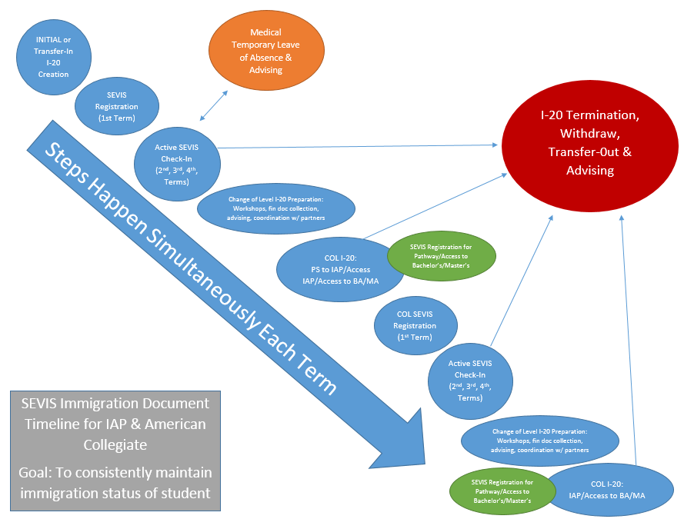
Immigration Document Timeline- Student View:

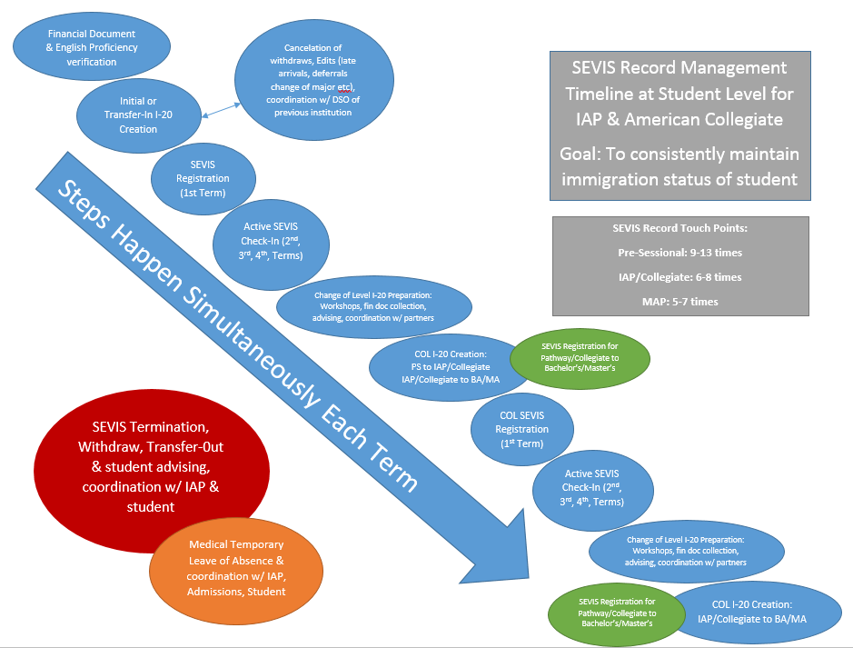
*Available in K-Drive/ISSS/01-IAP/Manuals

Addendum (COVID Note)
Progression (as of September 2021)
Due to the COVID-19 pandemic, the progression process has become complex. Typically, students progress from one program to another while holding active SEVIS status in the U.S. However, during the COVID time, students could enroll in online courses from outside the U.S. and meet progression requirements without holding SEVIS status. The below describes different student scenarios:
- Student has Active SEVIS status and progressing inside or outside the U.S.:
  - ISSS will issue COL I-20 upon confirmation of their progression. COL I-20 must be issued within 60 days of the program completion date. Students must enroll in in-person classes to come back to the U.S.
  - If students decide not to re-enter the U.S. in the semester they start a new program, their immigration record will be closed. (Cancel COL & shorten previous program) Students must request a new I-20 for the next available semester.
- Student has cancelled/initial SEVIS status and progressing outside the U.S. *Students cannot be in the extended term:
  - If students has F-1 visa issued under their previously issued canceled AU I-20: Submit a correction request through SEVIS to restore their old I-20 record. Correction request should be for change status to “initial”. This way, students don’t need to go through the visa application process again as the SEVIS ID between their visa I-20 matches.
    - For remarks in the correction request, write “The student was not able to enter the U.S. for Fall 2021 semester (or relevant semester) due to the COVID-19 pandemic. The student now hopes to enter the U.S. to attend in-person classes in the Spring 2022 semester (ore relevant semester).”
  - If student doesn’t have F-1 visa under their previously issued canceled AU I-20: Issue another initial I-20 so they can start the visa process. The I-20 is made with their current program information (PSE/IAP/MAP…etc.) although students are scheduled to progress to the next program at the end of the term. After they successfully complete their program & arrive in the U.S., SEVIS register them and create COL I-20 immediately after SEVIS registration for their new program.
  - If students have initial SEVIS record with the start date of Fall 2021: Update initial session start date to Spring 2022. The program information remains “Other: Pathway Program or Language Training” until their progression is confirmed at the end of Fall 2021 semester.
    - Once their progression is confirmed:
      - Students can enter the U.S. with the I-20

  - This scenario is possible only if students are NOT in the extended term (because they could be eligible for extension in the next term.)
  - If students extend into the next term & arrive in the U.S.
    - Keep the I-20 record as is and SEVIS register. Do not create COL I-20.
  - If students are administratively separated:
    - Cancel the initial I-20. Alert the students about cancellation of their I-20 before cancelling it since some students may enter the U.S. before administrative separation decisions are made. Work with JF to cancel/terminate students’ record in this case.
    - Students who enter the U.S. and are administratively separated must leave the U.S. immediately. They are not eligible to transfer their SEVIS record in active status.
- Students in “terminated” status (terminated transfer-in or terminated COL).
  - Terminated transfer in: Issue initial I-20
  - Terminated COL: Issue initial I-20. Students may try to use their previously issued unexpired visa but it’s safer
- Students in the extended term without SEVIS status/I-20
  - This is the most problematic scenario. Students in the extended term are not eligible to obtain I-20 for their current program for the next semester because they are in the absolute last term of their program. They will not be eligible to stay in the current program in the next term.
  - Ultimately, their I-20 can only be issued AFTER their progression is confirmed at the end of the term. The I-20, visa process, and arrival timeline would be extremely tight. (e.g. Extenders in the Fall 2021 without I-20 can only receive I-20 at the end of the Fall semester (mid-December). They must apply for visa & arrive in the U.S. by January 10, 2022. Considering there are many holidays around the end of the year, this wouldn’t give them a lot of time. Close communication with students is necessary.)

Newly admitted students not coming to the U.S. in F21:
- If students are enrolled in F21 but not coming to the U.S. (including continuing students who received initial F21 I-20) and intending to come in SP22, ISSS will update their F21 I-20 to SP22. No updated financial documents or new PIIRF is not needed.
- If students were admitted but withdrew from Fall 2021 after Fall 2021 I-20 was issued & reapply for Spring 2022, their I-20 record first must be canceled. Once their new admission record is posted for the spring semester, take one of the following actions:
  - If F-1 visa is issued under the canceled I-20: Submit “Correction Request” through SEVIS to change “Canceled” status to “Initial”. Notify students that their previous I-20 record was restored & they don’t need to pay the SEVIS fee again or go through the visa process.
  - If F-1 visa is not issued under the canceled I-20: Issue a new initial I-20 & notify students that they should transfer the SEVIS fee from the previous I-20 (if paid) to the new one.
Deferrals:
- If I-20 issued but not enrolling in Fall > admission offices need to approve deferral > PIIRF doesn’t need to be submitted for SP22 (ISSS can defer F21 I-20) but ISSS will confirm students’ deferral in their admission record. Students don’t need to submit updated financial documents to receive SP22 I-20 but they should update documents for their visa appointment & send ISSS a copy.
- If students defer from F21 to F22, students must submit new financial documents to ISSS to receive F22 I-20. PIIRF must be submitted by admission offices.
Cancellation:
- If students are denied of visa & students are not enrolling or not intending to attend AU in the future semester.
PSE in Fall 2021
- It was confirmed that PSE is offered only online in the Fall 2021 semester. Students who received I-20 for Fall 2021 will receive updated Spring 2022 I-20 (ISSS will differ I-20 program start date to Spring 2022 without PIIRF or updated financial documents)

COL students
- Students who received COL I-20 at the end of the spring semester or summer term but decided not to come back to the U.S. in the Fall 2021 will lose their immigration status. Their Initial COL record will be canceled (through the active record) and their previous active record will be completed.
- These students should be instructed to submit the Request I-20 form so they can submit updated financial documents and receive I-20 for Fall 2021. The I-20 process for Spring 2022 will start at the end of September (after SEVIS registration).

Student Scenarios around Change of Level

IAP/MAP students sometimes decide to take a temporary leave or defer to the next available semester right after successful completion of their pathway programs. Here’s the current protocol as of 12/04/2020 (per the email from Robyn)
Undergraduate IAP students who are on track to progress to CAS and KSB (the majority of undergraduate IAP students) and ask their IAP advisor about taking a “gap” are given the following information, which was agreed between IAP and CAS/KSB:
“IAP students who are on track to progress at the end of fall 2020 are eligible to apply for a temporary leave of absence once they have officially progressed to degree-seeking status. You should fill out the following form (https://www.american.edu/provost/registrar/pdf/upload/request-temporary-leave.pdf). Within the first two weeks of the semester, you need to submit the form to the Kogod advising team (ksbadvising@american.edu) OR College of Arts and Sciences advising team (ask-cas@american.edu)] and they will submit it to the Office of the University Registrar on your behalf. Please note, the deadline to apply for a leave of absence is within the first two weeks of the semester, therefore you should submit this form no later than February 1, 2021.”
ACDC students are referred to Office of Enrollment, where they request a deferral of admission. MAP students are referred to their department advisor/contact.

If students contact ISSS
While they are IAP students, their IAP advisor is the best place to start for any and all questions. In addition, they are welcome to contact academicteam@auaccelerator.com.

Communication regarding next steps for progressing students
This is a collaboration between units/schools and IAP. It happens towards the end of each semester, at a time that is convenient for the unit/school and IAP. This term, we started hosting these events during the final week of October and continued through Tuesday of this week.

Progression and Academic School Contact Information
IAP works together with the receiving school advising teams (UG) and department program directors (GR) to coordinate a hand off. Some schools plan information sessions that are online, live and synchronous. Others have created materials that are shared with progressing students, along with an assignment or step that students must take to become registered for the next term. All contact comes from IAP up until the formal hand-off has been made post-progression.

Notes: Jawee – August 2022 (Progression Information)

Hi Shannon,

Both IAP and ACDC extenders are sent a letter to let them know (1) that they did not complete the program successfully, but (2) they are eligible to extend, and (3) if they are not interested in doing so they must let us know as soon as possible or else be enrolled in program requirements for the fall. Rarely we have a student who makes a private decision not to extend without telling anyone, stops checking their email and disappears, in which case they're subject to falling out of status. Much as it pains us to see this happen, we cannot forcibly withdraw them without their written statement of intent.

Its much more common for them to extend, and IAP students almost always do so as they would have wasted a considerable amount of tuition dollars on our program with no reward if they choose to leave. Conversely, ACDC students may choose to forgo their extension offer if they've been accepted to AU (in which case Jordan's office is already PIIRFing them for the fall), or they've been accepted elsewhere, (in which case they're probably pestering ISSS about their SEVIS transfer). Either way they are rarely silent about their intentions as they usually need something from us. 🙂

We're always on the lookout for those potential uncommunicative extension "abandoners" and triple check with them as we approach add/drop. Even if they don't separate a request for voluntary withdra!al, we can do it on their behalf with a clearly written statement of intent. We'll let you know if we remain uncertain as to anyone's intention as we get closer to that point.

Take care,
Jawee

